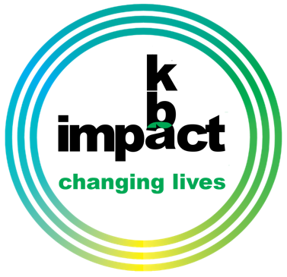
The Project That Will Have An Impact For Eternity

We have set a campaign goal of $900,000 that will allow KBA to complete the following:

- Strengthen and expand the existing foundation.
- Completely enclose the tabernacle with walls, windows, controlled entry and exits.
- Add heating and air conditioning.
- Upgrade the seating, stage area, and audio/visual systems.
- Create an outside venue attached to the front of the tabernacle for students to gather and fellowship.

www.kbaimpact.com

Four Ways to Give

First, prayerfully determine a financial commitment to the building project.
Second, consider what amount you will be able to give as an initial cash gift “up front”.
Third, in addition to monetary gifts, you may have other assets (such as stocks/bonds) you would like to donate.
Fourth, you may make KBA a beneficiary in your will. Your tax advisor can help you with this process.

Fifth, Set a church-wide goal for this special launch date offering to kick off our campaign.

FATHER’S DAY
JUNE 15, 2025

SPECIAL OFFERING

The Project that will have an impact for eternity

We have set a campaign goal of $900,000 that will allow to complete the following:

- Strengthen and expand the existing foundation.
- Completely enclose the tabernacle with walls, windows, controlled entry and exists.
- Add heating and air conditioning.
- Upgrade the seating, stage area, audio/visual systems.
- Create an outside venue attached to the front of the tabernacle for students to gather and fellowship.

Four ways to give

First, prayerfully determine a financial commitment to the building project.
Second, consider what amount you will be able to give as an initial cash gift “up front”.
Third, in addition to monetary gifts, you may have other assets -such as stocks and bonds- you would like to donate.
Fourth, you may make KBA a beneficiary in your will. Your tax advisor can help you with this process.

Existing Open Air Worship Tabernacle

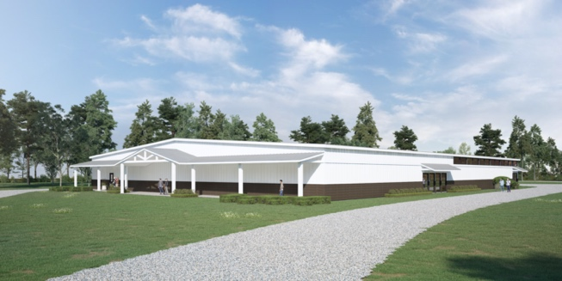

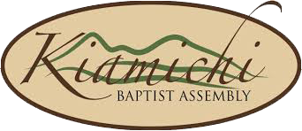

you can make an impact

The Project That Will Have An Impact For Eternity

We have set a campaign goal of $900,000 that will allow KBA to complete the following:

- Strengthen and expand the existing foundation.
- Completely enclose the tabernacle with walls, windows, controlled entry and exits.
- Add heating and air conditioning.
- Upgrade the seating, stage area, and audio/visual systems.
- Create an outside venue attached to the front of the tabernacle for students to gather and fellowship.

www.kbaimpact.com

Four Ways to Give

First, prayerfully determine a financial commitment to the building project.
Second, consider what amount you will be able to give as an initial cash gift “up front”.
Third, in addition to monetary gifts, you may have other assets (such as stocks/bonds) you would like to donate.
Fourth, you may make KBA a beneficiary in your will. Your tax advisor can help you with this process.

Fifth, Set a church-wide goal for this special launch date offering to kick off our campaign.

FATHER’S DAY
JUNE 15, 2025

SPECIAL OFFERING

you can make an impact

