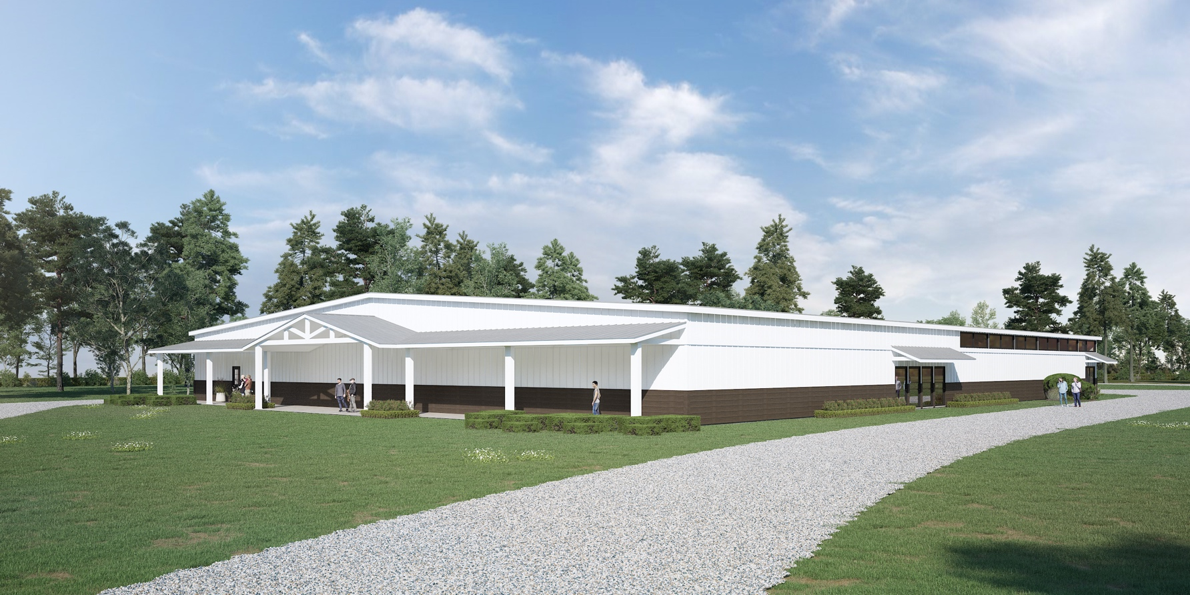

**CAMPAIGN KICKOFF DATE**

**FATHER’S DAY OFFERING ACROSS SE OKLAHOMA**

Project Will Include

* Strengthen and expand the existing foundation.
* Completely enclose the tabernacle with walls, windows, controlled entry and exits.
* Add heating and air conditioning.
* Upgrade the seating, stage area, and audio/visual systems.
* Create an outside venue attached to the front of the tabernacle for students to gather and fellowship.

OUR CHURCH GOAL IS $_____________

Campaign Goal: $900,000

www.kbaimpact.com